Computer Language Coding Concepts

Parameters
< Article text >

See also: < List of articles >

Author & Copyright: <Jan-Joost van Zon> Date: <May 21, 2008> – <May 22, 2008> Location: <Oosterhout, The Netherlands> Status: [ Under Construction | Finished | … ]

Ideas

Value Direction
Read-write direction is something so basic in computer language, that it has a separate line type. Value direction is indicated by a wavy line.

A value connection is actually not a real connection between symbols, but a value assignment.

A wavy line is actually a good symbol for it, because it looks like a less direct connection than the other line types. The wavy line looks like a less direct connection, because the complete length of the line, curves and everything, is much longer than a straight line. A wavy line also indicates heat, or activity, more than the other line types. Value direction is an action.

Read-write direction, input-output direction and value direction are synonymous terms.

Used in abstract notations, explained later, a value line does not necessarily mean yielding over the value of one object on one end of the line to the other object on the other end of the line. It may be yielding over values between sub-objects. So it’s not synonym to a value assignment in that case.
But usually value direction means assigning the value of one object to another.

A read of an output parameter is always accompanied by a write to another object. A write to an input parameter is always preceded by a read from another object. A read operation is always accompanied by a write operation. A value is read from one object, only to be written to another object.

In, Out & Thru
Parameters can function as input, output and throughput. Input, output and throughput are parameter passing types. They are shortened to In, Out and Thru.

When a command’s parameter is In, it means that the command reads from the parameter. When a command’s parameter is Out, it means that the command writes to the parameter. When a command’s parameter is Thru, it means, that the command reads and writes the parameter. Throughput functions as both input and output at the same time.

Before execution you can read and write.
During execution you can not read or write.
After execution you can only read.

By Value
Passing a parameter by value means, that the input or output is copied to or from the parameter object.

Parameters passed by value are really only useful for smaller amounts of data. The data might be changed inside the command, but that will not affect the original object.
For an object, that only stores one value and that’s it, it is easy to just copy the value. More complex objects passed by value will be cloned up until a certain cloning depth.

When pass an input parameter by value, it is guaranteed, that the operations inside the command will not affect the original object.

For that reason, when a value parameter is cloned up until a certain depth, no references to original objects will be taken over by the clone. By Value clones never have references to existing objects, but always contain entirely new objects or object references that are Nothing.

A single-value transfer is actually the equivalent of a cloning operation with a depth of 1.

If you want to pass more complex objects to a command, you do it by reference, but then changes to the parameter will affect the original objects.

In parameter passing by value, the parameter object and the object, that is passed the value to or from, are not referring to eachother at all.

By Value in a Diagram
The diagram below represents a By Value parameter tied to the value source or target:

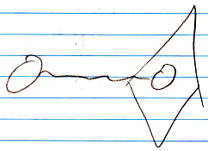

The diamond is the command. The circle inside it is the parameter. The circle outside the command is the value source or target. And the wavy line indicates value transmission between the parameter and the other object.

It is actually a value assignment, that performs a yield over of value.
Here is a diagram showing such a value assignment:

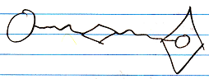

A value assignment does have an invisible reference to the parameter, but you won’t see it in the diagram, because an assignment is something so basic, that the notation of it is kept very basic.

The complicated notation:

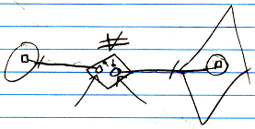

(the arrows are pointing to the references invisible earlier)

But this still does not tie the source and target symbols directly together.

The notation of a By Value cloning operation looks as follows:

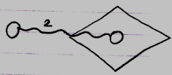

A single-value transfer will be the same as a cloning depth of 1, but the number 1 will not be shown then.

By Reference
Next to passing a parameter by value, you can also pass a parameter by reference. For instance: instead of copying a value to an input parameter, you give the command a reference to an object outside the command.

Reference parameter:

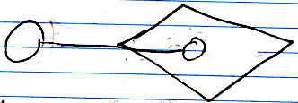

Therefore it can also be called Reference Outward, Value In and Reference Outward, Value Out But those names are too long. The distinction between Reference In and Reference Out is about whether values are read or written to the object passed to the sub-command.

In earlier programming languages one use of by reference was to be able to pass large objects to a procedure. Another use was to be able to let the procedure have multiple return values, because in other programming languages a procedure can really only have one return value. In the new computer language, multiple return values is accomplished by having multiple Object Out parameters. So you do not need Reference Out parameters for that purpose anymore.

When a command call has an outward reference to an object, this does make the object a parameter, but this does not determine yet whether it is input, output or throughput. The in and out in this case refer to whether values are written or read to the object reference. A reference parameter is always sort of like input, though: the parent command passes the object to the sub-command, so the parent inputs something into the sub command.

Indirect Value Transmission
For Reference parameters it does not need to be the value of the object itself, that is read or written.

It can also be a sub-object of the parameter, that is read or written. Even though the parameter itself is not read or written, but only its sub-object, the parameter itself is considered input or output, even though only the values of its sub-objects are used.

Sometimes the command itself does not read or write from a parameter, but the parameter is passed down to a sub-command, that reads or writes from the object. This yields over the in-out-thru properties of the parameter. This does give the parameter an indication of value direction, but this is an abstract notation of what is going on. The assignments are done by a sub-command.

Next to values being read or written, an abstract indication of value direction is also used to indicate addition, removal, creation and annulment of objects. These actions are all considered writing or output.
In the definition of the command, you will see the individual additions, removals, creations and annulments as calls to system commands (see the System Objects documentation section).
But the Reference parameter will get an abstract value direction indication, that says the reference parameter is output.

All in all, non-value transmissions apply to By Reference parameters only.

So for reference parameters, the in-out-thru direction will be an abstract indication of what is going on. It can mean a lot of different things. The exact objects and manipulations a command executes on a reference parameter are indicated by its command IO, covered in the article Command IO (possibly still part of the article Automatic Execution Order).

Value In
A Value In parameter passes a value from an object to the parameter of a command. A Value In parameter is an object inside the command call, that can be written before the command is invoked, by assigning to it a value of an object outside the command call.

The command can manipulate the Value In parameter without affecting the original object.

A Value In parameter works best simple objects, that stores a single value, but can also work for more complex objects, that will then be cloned up until a certain depth.

Value In in a Diagram
A diagram of an executable command with a Value In parameter:

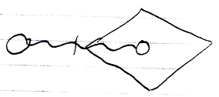

Here is a diagram of an unfilled-in Value In parameter of an executable command:

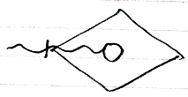

A Value In parameter can also have an indication of a cloning depth, which is displayed as follows:

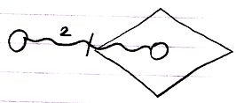

Or for an unfilled-in Value In parameter:

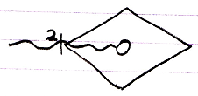

The pictures above display a cloning depth of 2, but any cloning depth can be used.

A command definition or other inactive command displays Value In parameters the exact same way. The Value In parameter of a command definition is usually not filled in:

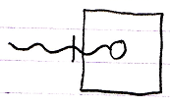

But the Value In parameter of an inactive command could be filled in just as well:

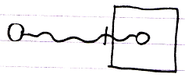

The fact, that it is an inactive command, means that it will not run, but for the rest it is the same as any other command object, so it basically has the same possibilities.

Here is the expression of cloning depth for Value In parameters of inactive commands, which is the same notation as for active commands:

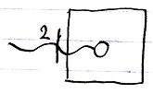

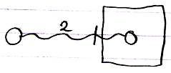

Value Out
A Value Out parameter is a value produced by a command, that can be yielded over to another object after the command is done. A Value Out parameter is an object inside the command call, that is written to by the command or by one of its sub-commands. After execution of the command the value of the output parameter can be copied, by assigning the value to another object.

As said in the article By Value, the parameter is either a copy of a single value, or a clone up to a certain depth.

Value Out in a Diagram
A diagram of an executable command with a Value Out parameter looks as follows:

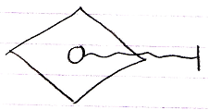

The following diagram shows the Value Out parameter with an assignment target indicated to which the output value will be transferred:

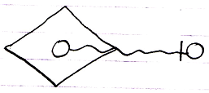

A Value Out parameter can also have an indication of a cloning depth, which is displayed as follows:

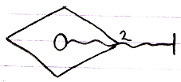

Or with the target of the output filled in:

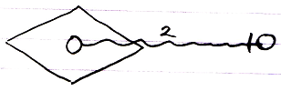

The pictures above display a cloning depth of 2, but any cloning depth can be used.

A command definition or other inactive command displays Value Out parameters the exact same way. The Value Out parameter of a command definition will look like this:

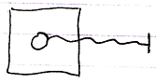

The Value Out parameter of an inactive command can also be read and written to a target object, like this:

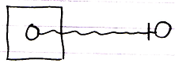

The fact, that it is an inactive command, means that it will not run, but for the rest it is the same as any other command object, so it basically has the same possibilities, even reading and writing its parameters.

Here is the expression of cloning depth for Value Out parameters of inactive commands, which is the same notation as for active commands:

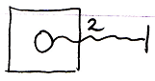

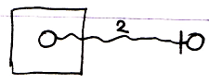

Value Thru
Throughput by value is when a by value parameter is first written to, then changed by the command, and then the value of the parameter is read from again, and assigned to the original object.
A Value Thru parameter is an object inside the command call, that can be written before the command is invoked, by assigning to it a value of an object outside the command call. It is used but also written to by the command or one of its sub-commands. After execution of the command the value of the throughput parameter can be copied, by assigning the its to another object.

As said in the article By Value, the parameter is either a copy of a single value, or a clone to a certain depth.

In theory the value could first come from one object, and after the call be written to another object. But that’s not regularly what a Value Thru parameter is used for. The value will first be copied from one object and assigned to the parameter, and afterwards the value of the parameter is copied to the original object again.

Value Thru in a Diagram
A diagram of an executable command with a Value Thru parameter:

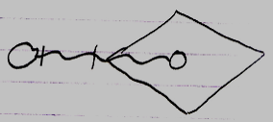

Here is a diagram of an unfilled-in Value Thru parameter of an executable command:

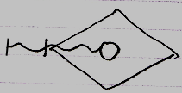

A Value Thru parameter can also have an indication of a cloning depth, which is displayed as follows:

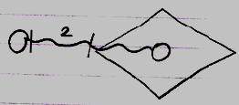

Or for an unfilled-in Value Thru parameter:

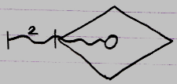

The pictures above display a cloning depth of 2, but any cloning depth can be used.

A command definition or other inactive command displays Value Thru parameters the exact same way. The Value Thru parameter of a command definition is usually not filled in:

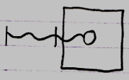

But the Value Thru parameter of an inactive command could be filled in just as well:

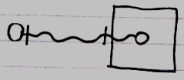

The fact, that it is an inactive command, means that it will not run, but for the rest it is the same as any other command object, so it basically has the same possibilities.

Here is the expression of cloning depth for Value Thru parameters of inactive commands, which is the same notation as for active commands:

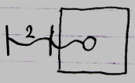

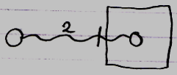

Reference In
A Reference In parameter can be used to assign a reference to a complex object as the input of the command. Because a Reference In parameter is input, the called command can only read out of the object, that it was given a reference to.

Reference In in a Diagram
A diagram of an executable command with a Reference In parameter looks as follows:

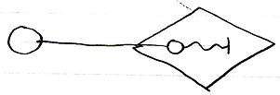

When a Reference In parameter does not have a reference target filled in yet, then the diagram looks as follows:

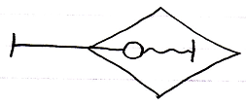

An inactive command displays Reference In parameters the exact same way. The fact, that it is an inactive command, means, that it will not run, but for the rest it behaves the same way as any other command object, so it basically has the same possibilities as an active command. The reference target of a Reference In parameter of an inactive command definition is usually not filled in.

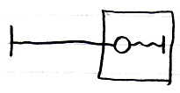

Here is a picture in which a command definition’s Reference In parameter does have its reference target filled in:

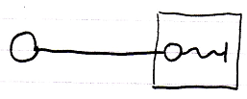

Do note, that the expression of read-write direction is not a connector point, like for Value parameters. It is an abstract expression of value direction. You can not connect anything to it. The reference target connector, however, is a connector point.

Reference Out
When a command is passed a reference to an object, and the command writes to the parameter, it is called a Reference Out parameter. Because a Reference Out parameter is output, the called command can only write to the object, that it was given a reference to. A Reference Out parameter can be used to assign a reference to a complex object to which a command writes output.

In a sense, a Reference Out parameter is actually throughput.
When output is alteration of an existing object, it could be considered throughput, even though there is only written to the object, and nothing is read from the object, it is still an object passed through the command. In yet another sense, a Reference Out parameter is input, because you are passing an object into a command.

Reference Out in a Diagram
A diagram of an executable command with a Reference In parameter looks as follows:

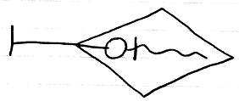

The access mark on the left is a connector point, to which the reference target of the Reference Out parameter can be attached. Here is a diagram in which a reference target is attached to the Reference Out parameter.

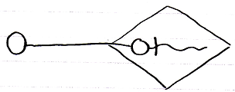

The fact that the reference goes outwards, does not make it an Out parameter. That just makes it a Reference parameter. The fact, that the command only writes to the parameter makes it an Out parameter, so the term Out is about value direction, not reference direction.

An inactive command displays Reference Out parameters the exact same way. The fact, that it is an inactive command, means, that it will not run, but for the rest it behaves the same way as any other command object, so it basically has the same possibilities as an active command. The reference target of a Reference Out parameter of an inactive command definition is usually not filled in:

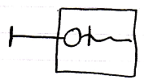

Here is a picture in which a command definition’s Reference Out parameter does have its reference target filled in:

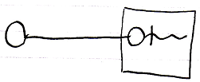

Note, that the indication of read-write direction is an abstract expression of the value direction inside the command. You can not connect anything to it.

Reference Thru
Next to Reference In and Reference Out, there is also Reference Thru, which means, that the command both reads and writes to the object passed to it. A Reference Thru parameter is a pointer to something outside the command. The object pointed to both read from and written to. A Reference Thru parameter can be used to assign a reference to a complex object, from which input is read and output is written to.

Reference Thru in a Diagram
A diagram of an executable command with a Reference Thru parameter looks as follows:

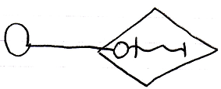

When a Reference Thru parameter does not have a reference target filled in yet, then the diagram looks as follows:

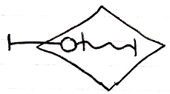

An inactive command displays Reference Thru parameters the exact same way. The fact, that it is an inactive command, means, that it will not run, but for the rest it behaves the same way as any other command object, so it basically has the same possibilities as an active command. The reference target of a Reference Thru parameter of an inactive command definition is usually not filled in.

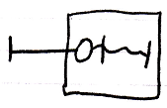

Here is a picture in which a command definition’s Reference Thru parameter does have its reference target filled in:

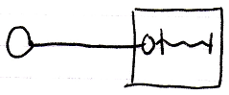

Do note, that the expression of read-write direction is not a connector point. It is an abstract expression of value direction. You can not connect anything to it. The reference target connector, however, is a connector point.

Object Out
An Object Out parameter is an object, that resides inside the command. The Object Out parameter may be a new object, or redirect to an existing object. Anyway, the command determines which object will be output. The produced object can be referenced from outside the command.

Unlike parameters passed By Reference, an Object Out parameter is referred to. This is an exclusive aspect of the Object Out parameter passing.

The long names of parameters passed By Reference were:

- Reference Outward, Value Inward
- Reference Outward, Value Outward
- Reference Outward, Value Thru

The long name of value Object Out is:

- Reference Inward, Value Out

So this is a Reference Inward parameter, as opposed to a Reference Outward parameter. The reference direction goes the other way around. Instead of a parent passing an object to the command, it is like the command passes a reference back to container of the command.

The command writes to the output object. Unlike Reference and Value parameters, there is no distinction between In, Out and Thru for Reference Inward parameters. The reason Reference Inward parameters do not have three variations, is that the command’s reading and writing values to the object is irrelevant to the parameter passing. To the outside, it does not matter whether the parameter is read from or written to or both. All that matters, is that an object is produced. Reference Inward, Value In and Reference Inward, Value Thru are not relevant. The Reference Inward parameter can be read from by the sub-command, but that it’s just not relevant to parameter passing between a command and its container. Because Reference Inward, Value Out is only relevant for reading values from an output object, it is shortened to Object Out.

An Object Out should really only be accessed after the command has run.

Object Out in a Diagram
A diagram of an executable command with an Object Out parameter looks as follows:

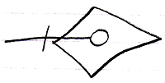

The outer end of the line is an connection point to which you can connect an object to refer to the Object Out parameter:

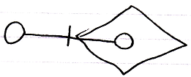

An inactive command displays Object Out parameters the exact same way. The fact, that it is an inactive command, means, that it will not run, but for the rest it behaves the same way as any other command object, so it basically has the same possibilities as an active command. The object refererring to the Object Out parameter of an inactive command definition is usually not filled in.

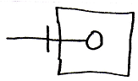

Here is a picture in which a command definition’s Object Out parameter does have a referrer:

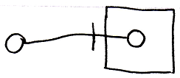

Three Parameter Passing Elements
By Value, Reference Outward and Reference Inward are the different reference situations a parameter can have. But this tells us nothing about whether a parameter is input, output or throughput. What determines, whether it is in, out or thru is whether values are written to the parameter or read from the parameter.

So the long names of the different parameter passing types are:

- Value In
- Value Out
- Value Thru
- Reference Outward, Value In
- Reference Outward, Value Out
- Reference Outward, Value Thru
- Reference Inward, Value Out
- Reference Inward, Value In
- Reference Inward, Value Thru

Reference Inward, Value In and Reference Inward, Value Thru are not relevant, because an reference inward only is about an output object.

It is important to keep understanding that there are three elements to parameter passing:

- Values read or written
- Parameter is a reference outward
- Parameter is referenced from the outside

To understand how the different parameter passings came about, it is important to keep those three aspects in mind.

Here is a list of the parameter passings, with their short names, and their diagram expression:

- Value In

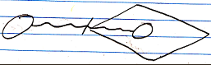

- Value Out

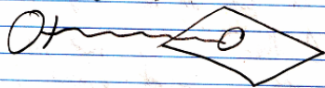

- Value Thru

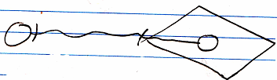

- Reference In

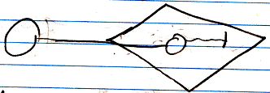

- Reference Out

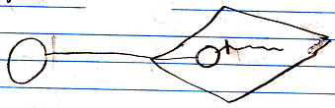

- Reference Thru

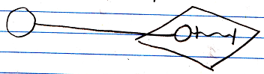

- Object Out

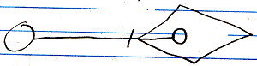

The reason why it is important to keep understanding the three aspects of parameter passing, is that Rerefence parameters, even though they can be In, Out or Thru, are always input in a way, because it is a reference passed from the parent command to the sub-command.

Value In and Value Out means reading and writing done by de caller. Reference In and Reference Out means reading and writing done by the called command. In both cases In does mean, that the called command uses something, and Out means, that the called command returns something.

Downput
Next to the terms input, output and throughput, the term downput will be introduced. Downput is intermediate data as a helper of a process, that will eventually produce output. Temporary variables, local variables. They are all downput. Actually, in the command-call structure, a command in which output data is disposed, this output has become downput.

Downput data is private data of the command.

The term downput is a good term, because it is only passed down into sub-commands. And it is dropped after the parent command is done (dropped down). It is ‘put down’ / rejected after the execution. Or put down / to put something down, that you had in your hand.

When a command disposes objects after it is done, then those objects are called downput. Downput may have been input for sub-commands, or it could have been output of sub-commands. To the parent command, though, it is downput. Downput parameters will not be further considered here, because they do not have anything to do with parameter passing.

Parameter passings are access control
Parameter passing types are a form of access control, limiting the possibilities, in order to give guarantees about the parameter’s behavior. This is why you can’t just reference each parameter. You can only reference a parameter when it is Object Out.

If a parameter is for instance Reference Thru, the parameter can only point to something, but you can’t refer to a Reference Thru parameter. You can only refer to an Object Out parameter.

The target of a Reference parameter is only set by the caller, and can not be changed by the command itself. The command as such, can also not replace the target of the Reference parameter by a new object. To return a new object or another existing object, you have to use an Object Out parameter.

The target of an Object Out parameter is determined by the command, and can not be changed externally. That can only be done to a Reference parameter.

Parameters of calls directly tied together
In other programming languages, sub-commands do not directly read or write to eachother’s parameters. Parameters are only read or written by the parent command.

However, in the new computer language, parameters of commands can be tied together directly.

One parameter type can only be tied to a parameter with specific other parameter type.

Value In parameters and Value Out parameters can only be tied together:

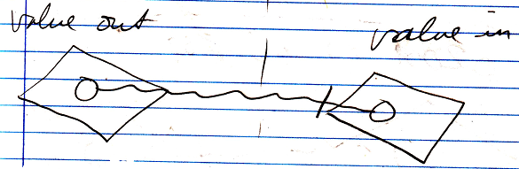

Only Object Out and Reference parameters can be tied together:

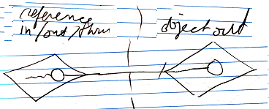

Tying parameters together directly states a direct dependency. No direct reference to the parameter objects are required inside the parent command.

A Value Thru parameter can not be tied to another parameter:

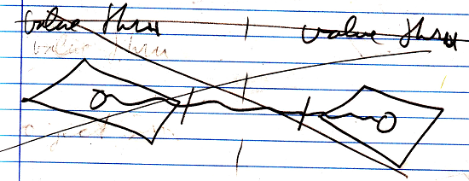

This is because it creates a circularity in which one parameter writes its values to the other, and the other parameter writes its value to the first parameter. It is just an unlogical circular situation.

When directly tying together value parameters, cloning depth can be intermixed:

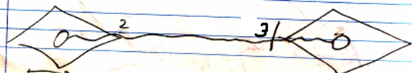

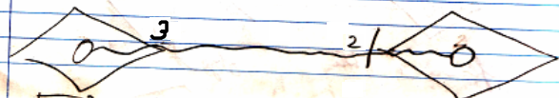

Effectively, it will be the lowest cloning depth that will be transferred to the input parameter on the right. When the Value In and Value Out parameters have the same cloning depth, it is drawn out as follows:

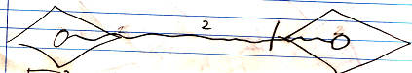

Strict about parameter passing
I really want the programming environment, to not so easily accept, that a parameter is typed throughput, when it is only read from. Because otherwise you rely too much on courtesy of the programmer, to make the whole system function correctly.

You could define a parameter as throughput, but actually only read from it. In that case the parameter is implicitly degraded to an input parameter. The implicit parameter type counts. The implicit parameter passing is dependant on the way it is declared and the way it is used. A throughput parameter is not only declared as such, but also always used as such.

Incidental parameter passing
One time a command runs, something may only be read. Another time it may be read and written to. This changes the implicit position of the object in relation to to the command for each call to the command. You could stereotype it an input parameter as Not Input and an output as Not Output and a thru parameter as Only Input or Only Output or Not Thruput. But it does not replace the parameter’s In, Out or Thru properties, because they belong to the command definition.

The object command’s on the other end of the relationship, also get additional typing based on the incidental parameter passing, but the passing names are not even determined yet.

Newer articles (2008-09-09)

Brainstorm
The basic Command articles are read over in search of more parameter passing types. A few particular situations are found.

They are two elements:

- Parameters, that are commands
- Parameters, that are classes or have classes

In essence any situation is possible where parameters are commands or parameters are classes or parameters have classes. But parameter passings are not the various situations a parameter can have, but parameter passings are access control over those situations.

So it is a matter of: which features have to be access controlled in the situations:

- Parameters, that are commands
- Parameters, that are classes or have classes

Reading and writing are less relevant to access control for parameters, that are commands. Being or not being able to execute a parameter, that is command might be an issue.
Whether a command can have a class, assigned by the parent command, or a class, assigned from the outside might be access controlled.
Whether a command can only be used as a class from the inside, or only be used as a class from the outside.
Whether a command can both be used as a class and as an object from either outside or inside.
Value parameters are less practically usable for parameters, that are commands.

The thing is: in essence it is all possible. But access controlling it will give guarantees about the command’s behavior. Guarantees, that might be essential for automatic execution control, concurrency resolution and user controlled access control, so a user can make a decision about the usage of a command, based on what is done with the objects passed to it.

The object parameter passings needs were already covered.
To what extent were those parameter passing types only adapted to the specific needs of object parameters? Or to what extent were those parameter passing types more universal?
But the needs for parameter passings of parameters that are commands are not covered yet. Can I make specific practical parameter passings especially for parameters, that are commands? Will I limit the possibilities too much, when I do that?
I have already limited it for object parameters too: you can not reference a parameter, and have it be a reference itself. Reading and writing a parameter from the outside is access controlled, but reading and writing a value parameter from the inside is not access controlled.
Can I make specific practical parameter passings especially for parameters, that are classes? Should I stop object parameters from ever being classes as well?

Gee, reading over command basics does introduce a lot of issues about possible new parameter passings. This really needs to be carefully thought through. It seems to introduce more than I thought. I can now think of more parameter passings, than were already there in the set of normal object parameter passings.

Disturbing…

Parameters that are commands
Next to normal objects being parameters, commands can also be parameters. Commands are objects just like any other, with the added property that it can execute. The articles, that follow, will explain the uses of commands in any possible parameter passing situation.

Reference parameters that are commands
A Reference parameter, next to being able to be a normal object, can also be a command object.

When a Reference parameter is a command, then it can be run by the parent command, that has a reference to it. This does not let any other parent command loose control over the execution of its sub-command, because you cannot reference another command’s sub-command. A Reference parameter can only be a reference to an active command inside a normal object.

When a Reference parameter is a command object, then it could also be used as a class target inside the parent command. So a parent command can use a parameter, that is a command Reference as a prototype for another command object to execute.

When a Reference parameter is a command, it can also be passed to a sub-command again.

< The In, Out and Thru properties may not apply as much to reference parameters that are commands. Reading and writing values from a command means setting and getting its own parameters, and mostly there is no point to having a command reference, from which you are disallowed to either write input or read output. So most reference parameters, that are commands will just be Reference Thru parameters, so that you can write its input parameters and read its output parameters. Perhaps a Reference parameter, that is a command, can only be Thru. >

< The parent of the Reference parameter, that is a command object, will always be able to reference its own Reference parameter, so internally inside the parent command, you can always use such a parameter as a class, or redirect to it with a command reference.>

< Being able to execute a Reference parameter, is a different deal, though. Being able to execute a reference parameter might need to be access controlled, just like In, Out and Thru is access controlled. Perhaps only allowing a parameter to be a class reference, adequately controls this. But what kind of parameter would it be then? A parameter that is only a new object with a class reference to the outside? >

Object Out parameters that are commands
An Object Out parameter can be a regular object, but it can also be a command object. In that case it is a command produced by another command. The parent command can return a new command or the parent command can return a reference to an existing command.

New command
When an Object Out parameter is actually a new command, then the new command is either a preconfigured instance of another command, or it can be a brand new, generated command, any part of which is constructed by its parent command, based on a set of variables.

Existing command
An Object Out parameter can also be an existing command. In that case the Object Out parameter object-redirects to another command again, so the parent command basicallly picked out a command for you, instead of actually producing a new one.

The class of a parameter
The class of a parameter is usually set by the command, that holds the parameter. In that case, you can only assign objects or value of objects to it, that have the same class as the parameter indicates.

It is also possible, that a parameter does not have a class. In that case any object or any object’s value can be passed to the command.

When the class of a parameter is determined from the outside, then it is special. It is a Class Reference parameter. In that case you may not be able to also use it as a normal Reference parameter. < I don’t know yet. >

The class of a parameter, that is a reference

Public active command references inside commands
Public active command reference inside a command might be a Reference parameter, that points to something on the outside. If a

Sub-commands are never output objects
Sub-commands are never referenced so sub-commands can never output objects.

The rule is explained in the article Sub-Commands are Never Referenced, as part of the set of rules that protect a parent command’s control over the execution of its sub-commands.

This rule also implies, that sub-commands (active commands inside another command) can not be output objects. If the rules that protect the parent’s control over its sub-command’s execution change, then the rule sub-commands are never output objects might not apply anymore.

< A parameter, that is a command reference, can be run, but it can never point to an active command inside another command, so that never lets any parent command loose control over any sub-command’s execution. >

Other Ideas

Consider later: More parameter passings
Parameters,
2008-08-07

Make sure you mention everywhere, that a command reference is considered data, and can be a parameter as well.

JJ

Consider later: Relations between commands & objects
Parameters,
2008-08

Have I even considered what commands and classes loosely coupled means in the notation of command calls upon objects? I think I have only considered command definitions in classes, not command calls upon objects…
If a parameter is a command’s object, then parameter passing notation has to also display object command definition calling. So the parameter type notation is incomplete.
Does that only apply to reference parameters?

JJ

Parameters,
2008-08

The command definition can also contain a set of related objects. Those are the parameters of the command. They are just input, output, throughput or downput. This input, output, throughput and downput is passed on to the sub-commands, that are given outward references to these items (the parameters of the sub-commands are pointers to pointers that way). Some parameters may become required, so that you have to fill them in, or have to use them as output.

JJ

Computer Language,
2008-08-28

None of the parameter notations have dual relations with the objects they reference.

Consider commands & classes loosely coupled:

“It ties its parameters to command references inside other objects, making it look like a call upon multiple objects, each of which is an argument of the execution.”

JJ

Parameter passings,
2008-09-05

If a command parameter is typed with in, out, or though,
then an object command can also be given a title depending
on whether it will be input, output, throughput, etcetera.

input is not an object that something is done to. It can be considered an object doing something to another object. So it is clearly an actor.

It matters whether the object is used (read), affected (written), or produced. This alters the object’s position in relation to to the command.

JJ

Parameters,
2008-06

An Object Out parameter can never be considered an object called upon, because the output parameter only exists after the call, not before.

JJ

Parameters,
2008-06

Always something is the input and something is the output: at least one thing is used, and at least one thing is affected. But the affected thing can also be a new thing
One thing is executed on another. So its data executed on data.

JJ

Relations between objects,
Value parameters,
2008-09-09

Value parameters do not have the interchangability between command parameters and object commands, because they are not a relationship.

JJ

Consider later: legacy and misc concepts
Parameters,
Parameter Order,
2008-08-17

“After the output has been read (which means: written to other objects)…”

The parameters are not really a list of objects passed to the call anymore. The call is an object, that has a set of object references in it, that are individually set.

JJ

Parameters,
2008-08

Required return value: unable to execute without picking up the return value.

JJ

Consider later
Parameters,
2008-08

When you pass a property as a byref argument, and the procedure reads and writes from the byref parameter, you want the property get and set to be called. Does that require a pointer to a pointer to a pointer or what?

JJ

Static,
2008-06

A local variable may make the method a static method of a class, instead of a method of an object?

JJ

